**+National University of Computer and Emerging Sciences** 

# Software Engineering



**“Project Report”**

**Group Members:**

* Yahya Kamran I21-0701
* Amna Khan I21-0665
* Hareem Zaigham I21-0426

**Degree Program:** BS-CS

**Section:** B

**Subject Name:** Software Engineering

**Date of Submission:5 May 24, 2024**

**Introduction:**

Our project involves the development and implementation of an One-Stop online degree issuance system. This system features an intuitive and user-friendly interface, allowing students to easily submit degree issuance requests and correct any errors in their data. Automated notifications should be incorporated to keep students informed at various stages of the process, providing updates on the status of their requests. Additionally, the system should employ automated data management processes to minimize manual errors, ensuring the accuracy of student information. This comprehensive solution aims to enhance user experience, streamline administrative workflows, and significantly reduce the time required for degree issuance while maintaining data integrity.

**Project Rational:**

We designed this system because there are currently not many smart apps being used in this institution that provide facilitation to both the employees like admin,lab technicians ,Faculty and students of this university. The app allows such users to create their accounts and avail the different facilities provided.The development of this system addresses the need for a efficient process.In the current existing system that students visit in campus the entire process is prone to errors and delays and the user experience can turn unpleasant and inefficient

To address these challenges our team has come up with the ultimate solution to leverage it according to the modern technologies and follow the latest practices.This system aims to reduce the user time required for degree issuance and less efforts required while maintaining the data integrity and securing private information

* User friendly interface to submit request and track
* Administration staff can efficiently manage the request submitted
* Timely processing is ensured throughout
* Reduction in manual follow ups
* Improving transparency of process
* Automated notification to inform students
* Accurate data storage
* Data integrity and reliability enhanced
* Scalable system
* Minimum manual eros on automated data management
* Three tier layered architecture
* All layers separated making it easy to maintain system
* Ease of development
* Ease of deployment
* Testing process made easier
* User centric and robust technology solution to sooth the entire process

**Project Architecture:**

Our one stop online system is following a three-tier layered architecture that is composed of a presentation layer as well as database and business logic layer .

**1-presentation layer**

user friendly interface to make the interaction between the system and the user easier .

Implemented using technologies like C# and microsoft server management studio for database connections

Users including students faculty and admin can interact through this layer

**2-Business logic layer**

This layer comprises of the core functionality of this management system and has the main processing logic

Implemented with sql to handle server side operations

The admin is responsible to make sure authenticated users and reaching to the system only .Admin receives the degree issuance request as well as notifications and other functionalities of the system

**3-Database server**

The database layer is responsible for storing and managing the data of all students and faculty members using the system

implemented using sql(microsoft server management studio) to store all records and requests notifications and other data

Ensures the integrity reliability of the data and maintains systems scalability

**Product Backlog:**

*Table 1: Product Backlog*

| **ID** | **User Story** | **Estimate** | **Priority** | **Acceptance Criteria** |
| --- | --- | --- | --- | --- |
| 1 | As a student I want to seek career counseling from different experts so that I can choose my degree more easily | 1 hr | 19ab ha | * .Given that students need counseling in selecting a suitable program and they are logged in to * the system when they press the link for career counseling services then students should have * access to academic advisors and counselors to choose among them |
| 2 | As a student with a walking disability, I want to receive appropriate accommodations and  scholarships based on my needs. | 1 hr | 20 | Given that a student with a walking disability applies for scholarships when the student provides  the necessary proof through the application process, then the career counseling services  should review the request as soon as possible and provide accommodations and scholarships  for that student as well. |
| 3 | As a society leader I want to organize a student fair so that students can learn about different  universities | 1 hours | 21 | Given that the participating universities are present, when the society leader communicates with  each university representative, the representatives should make sure to tend to all the students  qualms. |
| 4 | As a student i want to apply for transcript issuance so that i can apply to a university abroad | 3.5 hours | 4 | Given that the student submits a request to issue their transcript, when the institution verifies the  student&#39;s identity and roll number, then the institution should tend to the request and provide the  printed form of the transcript. |
| 5 | As a student, I want to submit a degree issuance form online so that I can initiate the process of  obtaining my degree | 2 hours | 1 | * Given that the student fills out the request to ask for an issuance of the degree when the student * provides accurate personal and academic information, then the student council should provide * the student with the degree as soon as possible. |
| 6 | As a student, I want to track the status of my degree issuance request to know its progress | 0.5 hours | 2 | Given that the student fills out the request to ask for an issuance of the degree, when the  system retrieves the request information then the system should display the current status of the  degree issuance request, including any progress made or delays. |
| 7 | As a one stop admin, I want to provide students with admit cards so that they are allowed to sit  in exams | 1 hours | 3 | Given that a student is registered for an exam, when the exam date approaches, then the one-  stop admin should initiate the process of issuing the admit cards to all the registered students. |
| 8 | As an admin, I want to issue new ID cards to students so that they can enter the university. | 0.5 hours | 5 | * Given that a student is newly enrolled or lost his ID card, when the admin asks for the details of * his roll number and takes the necessary fees to issue another ID card, then the admin should * issue the card to ensure that the student can enter the university freely. * . |
| 9 | As an admin, I want to offer technological support so that students can take online classes  without any hindrance | 0,5 hours | 9 | * Given that students require technological support to attend online classes for each subject when * the university cannot be attended due to holidays or mishaps such as revolts, the admin should * promptly respond to such situations and enable online classes, to ensure that students can * comfortably take their classes from the safety of their homes. |
| 10 | As an admin, I want to conduct detailed orientations to ensure every student is informed about  the universities offerings and knows what to expect. | 1.5 hours | 10 | * Given that the orientation is taking place, when a student requires a basic idea regarding what * to expect during their time at the university, then the admin should provide detailed information * regarding academic programs, extracurricular activities, and any other events that may occur * during the student&#39;s time at the university. |
| 11 | As an admin, i want to provide every student with their corresponding fee challans so that the  students can pay the fee before the due date | 2.5 hours | 6 | * Given the need to issue fee challans to students, when the time to issue the challans to * students approaches, then the admin should generate timely fee challans for each student. |
| 12 | As an admin, I want to keep track of the lost and found section so that I can ensure that  students can always retrieve their lost items. | 2 hours | 7 | * Given that an item is lost and put into the lost and found section, when the student reports that * lost item, then the admin should check all the details of the lost item and return it if the user is * able to validate his ownership of that item. |
| 13 | As an admin, I want to track faculty hires to ensure we are never short on staff. | 1 hours | 13 | * Given the vacancy of a position in the faculty, when the applications are received, the admin * should review all the predetermined criteria and choose the person most suitable for the * position. |
| 14 | As an admin, I want to confirm that all outstanding amounts and degree issuance fees are paid  before approving the degree issuance. | 1.5 hours | 8 | * Given the verification process, when checking for outstanding fees, then the admin should * review the financial history of the student to identify any unpaid fees and inform the student of * the due date. |
| 15 | As a student, I want to submit a complaint form for issues like spelling mistakes in my degree  details so that they can be rectified. | 1,5 hours | 9 | Given that a student is logged in and is scrolling on the homepage the student clicks the  “submit complain” button then the link to the google form appears and then they can submit their  complaint through that form |
| 16 | As a student, I want to receive notification once my degree is ready so that I can collect it. | 1 hours | 16 | Given the fact that the degree is being processed, when the student&#39;s degree is ready, then the  admin should send a notification to the student via email to inform him that his degree is ready  to be issued. |
| 17 | As an admin, I want to set different thresholds for every departments test scores so that we can  filter and accept the most capable students. | 1.5 hours | 17 | * Given the results of the entrance exams, when evaluating the applicants, the admin should * prioritize those applicants who meet or exceed the department threshold while keeping the * number of available seats in mind. |
| 18 | As an administrator, I want to review shortlisted candidates so that I can identify suitable  candidates. | 1 hours | 18 | Given that the admin wants to track the Admission process when they access the status  tracking feature then they should be able to review those shortlisted, rejected, interviewed or  selected student and provide feedback accordingly |
| 19 | As a student, I would like to be notified as soon as Im enrolled so that I can decide whether I  would like to join the university or not. | 1.5 hours | 16 | * Given the completion of the admission process, when a student is eligible to enroll in the * university, then the admin should send a notification to the student to inform them that they can * now eligible to enroll into the university if they would like to. |
| 20 | As an admin i would like to provide students with a feedback module so that i can be aware of  the improvements needed | 1 hour | 17 | Given that a user is scrolling homepage and they are logged in when a user clicks the feedback  button then the link to different courses appear then they can submit feedback of desired  course |
| 21 | As a director I would like to update the new policies so that the students can review changes  made. | 1 hour | 18 | * Given that the changes in the academic policies need to be communicated to the students when * all changes are approved then the system should facilitate circulation of this information through * notifications. |
| 22 | As a student, I want the ability to correct errors in my degree details easily. | 1.5 hours | 14 | Given that the student has identified an error in their degree details when they access the  university’s degree-correction submission then they should be presented with a user-friendly  interface to initiate the process easily. |
| 23 | As an alumni, I want access to a platform where I can connect with fellow alumni and current  students, share experiences and enlighten the students about different career opportunities. | 1 hour | 15 | Given the discussion forums, when the alumni wants to share their relevant experiences, they  should be able to provide their advice in current career paths and job opportunities |
| 24 | As an admin, I want to be able to book campus facilities such as auditoriums and meeting  rooms for events and meetings through an online booking system. | 1 hour | 13 | * Given the availability of an online booking system, when an admin logs in and wants to book a * facility, they should be able to book the available facilities in the campus. |
| 25 | As a student, I want to participate in a mentorship program where I can be paired with a teacher  affluent in that field, who can provide guidance and support in my academic and career pursuits. | 1 hour | 12 | * .Given the availability of a mentorship program, when a student shows interest in joining any * such program, then the student should be provided with the information on which program to * join and how to do so as well. |
| 26 | As a graduate student, I want access to research opportunities such as assistantships and  grants to pursue research projects in accordance with my academic interests and career goals. | 1 hour | 10 | Given the availability of research opportunities, when a student shows interest in partaking in  such research facilities, the student service council should provide information regarding the  related research opportunities. |
| 27 | As a student, I want assistance in finding internship opportunities relevant to my field of study to  gain practical experience and increase my opportunities to get admissions for further studies  and employability. | 1 hour | 11 | * Given the availability of internships, when a student shows interest in doing internships, then the * university should provide information on relevant available internship opportunities to the * students field of study. |

**Project Planner and Gantt Chart:**

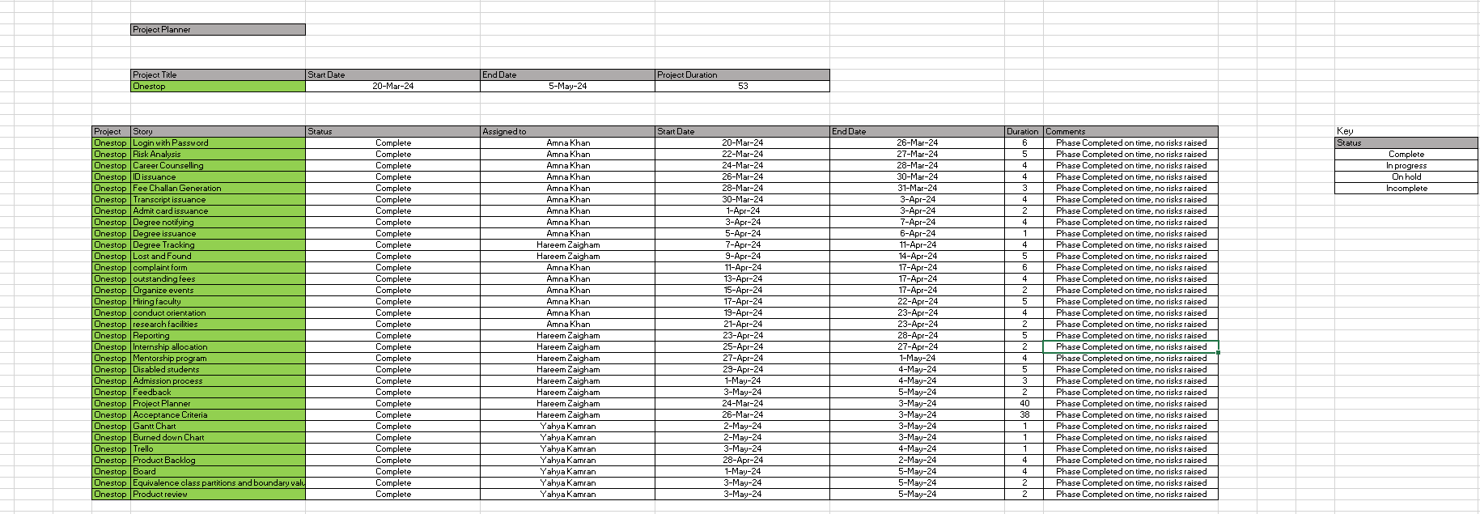



Gantt chart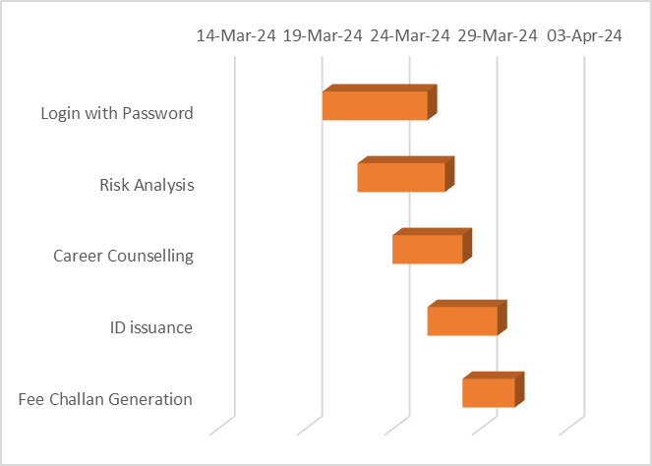



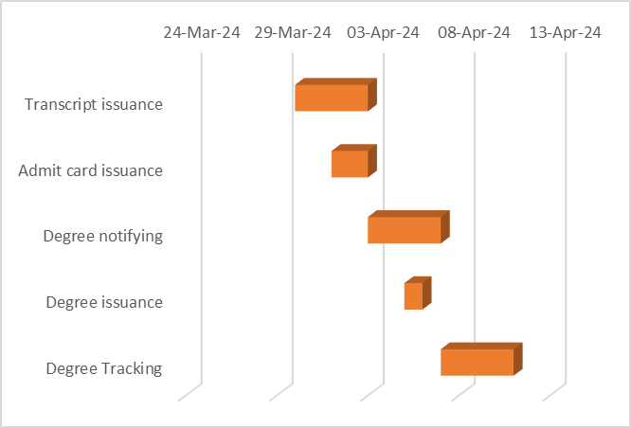

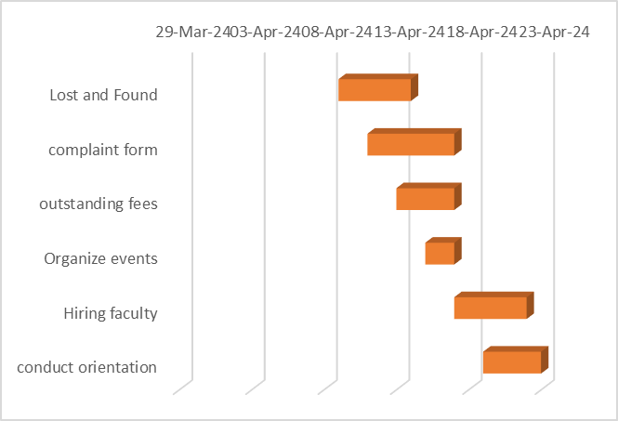

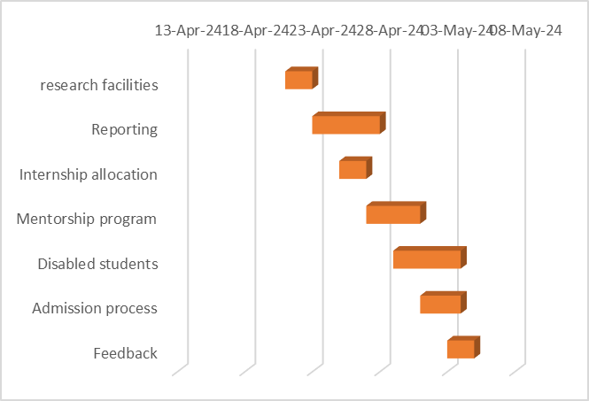

**Product Burndown Chart:**

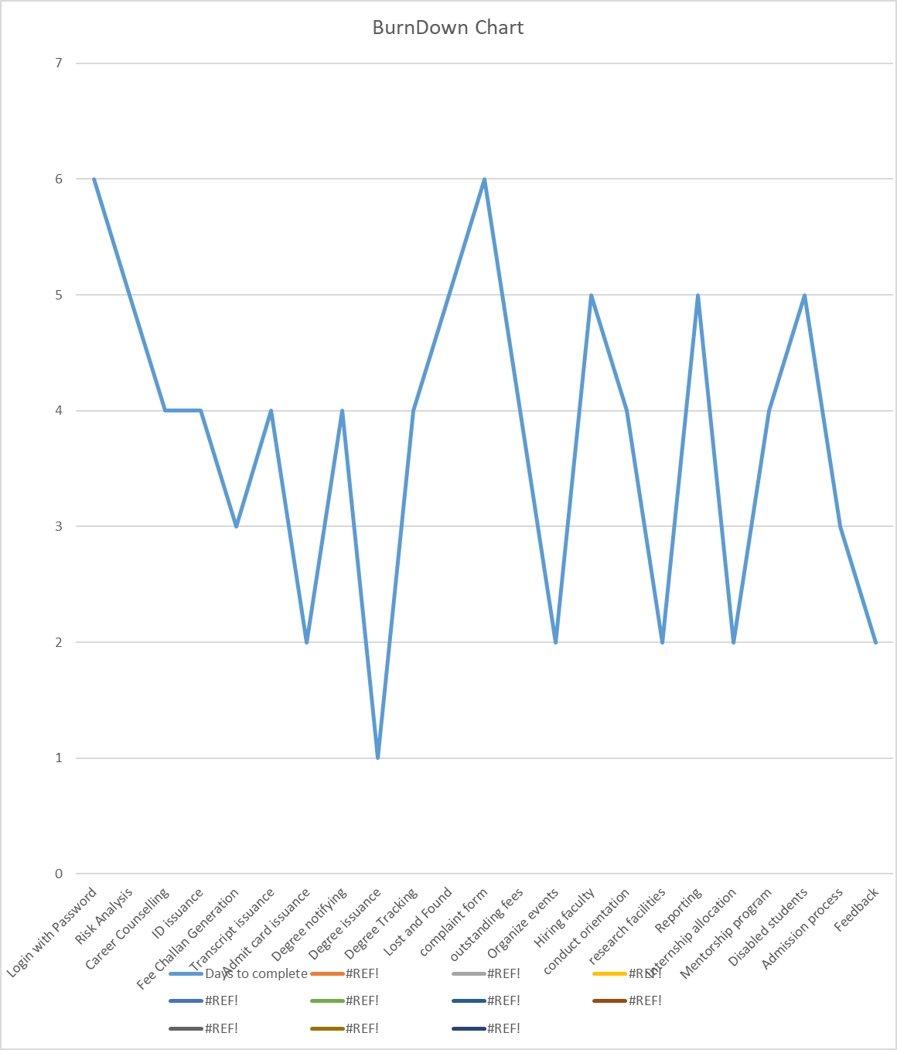

*Figure 18: Product Burndown Chart*

**Trello Snapshots:**

**Sprint-1:**

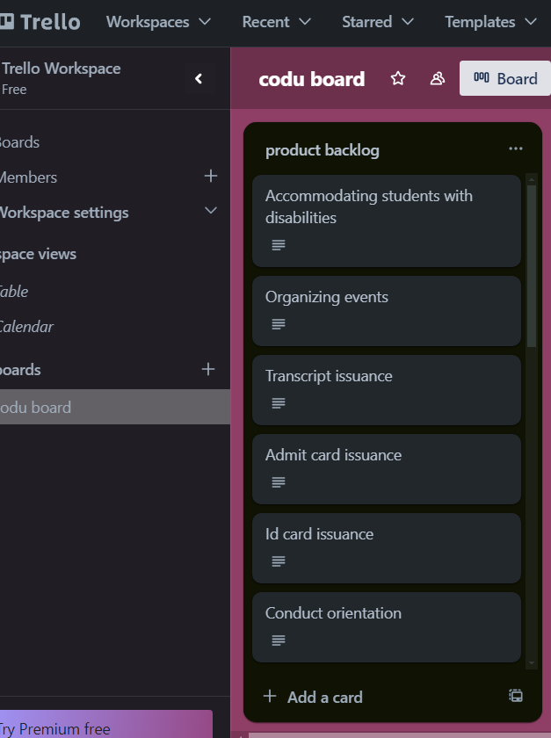

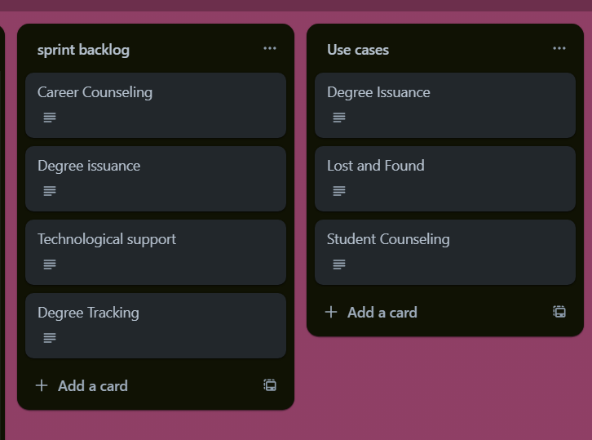

**Sprint-2:**

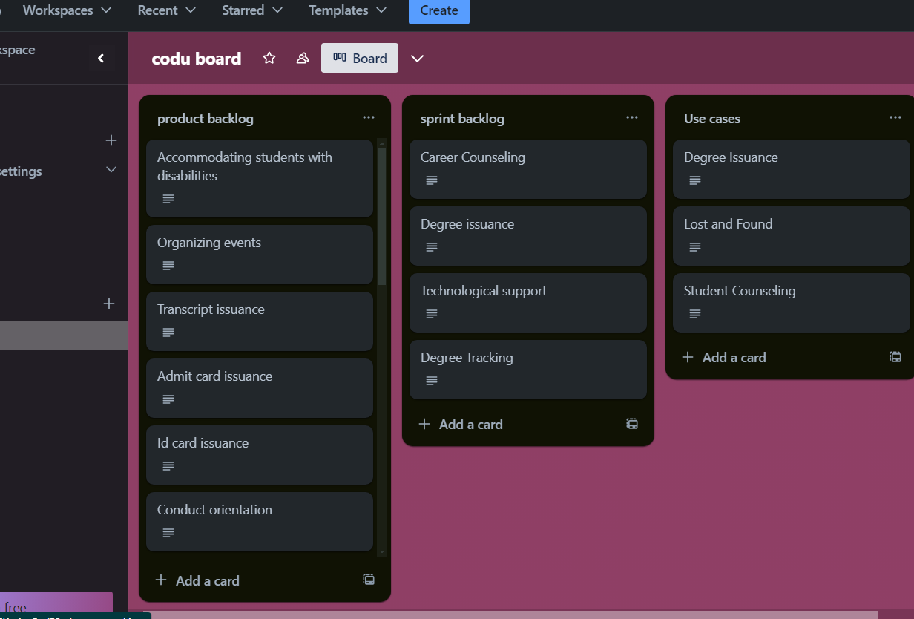

**Sprint-3 (Project Completion):**

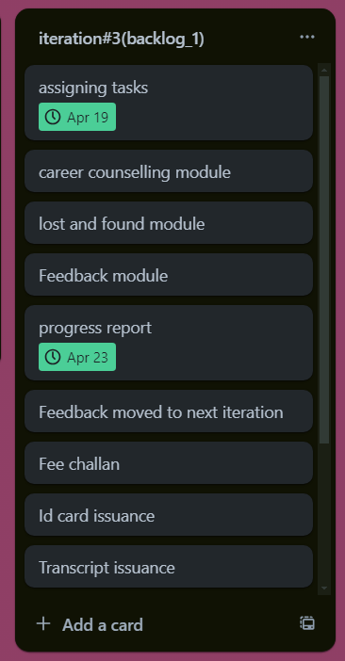



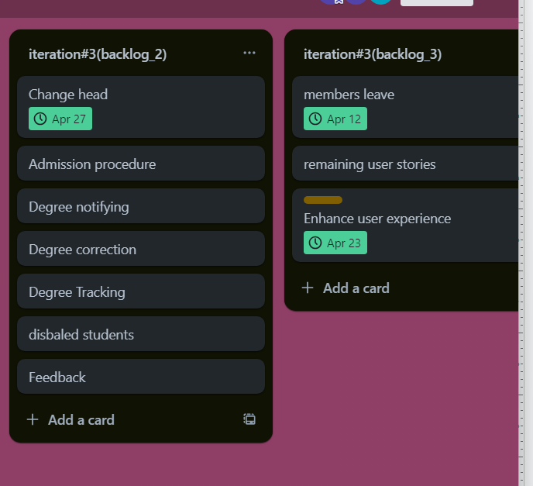

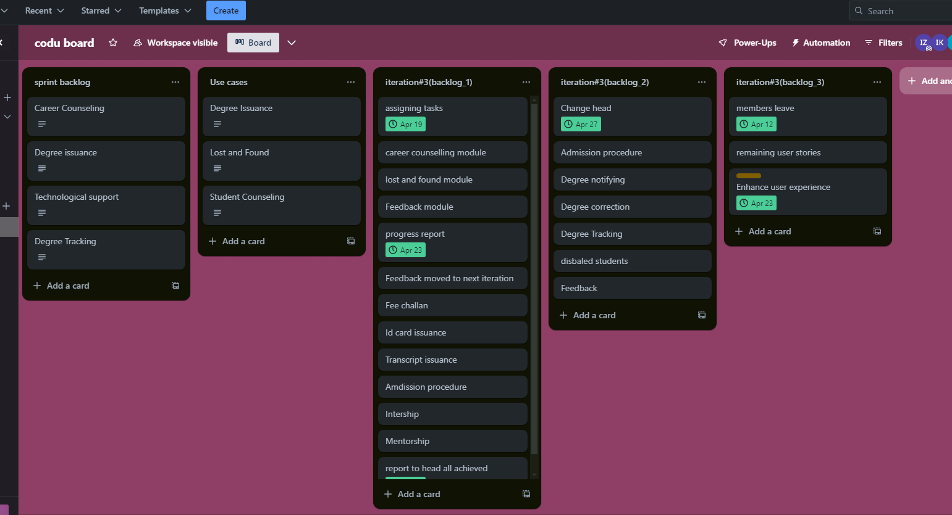

**GUI of Project:**

You can Choose one of the following doctors for an appointment.

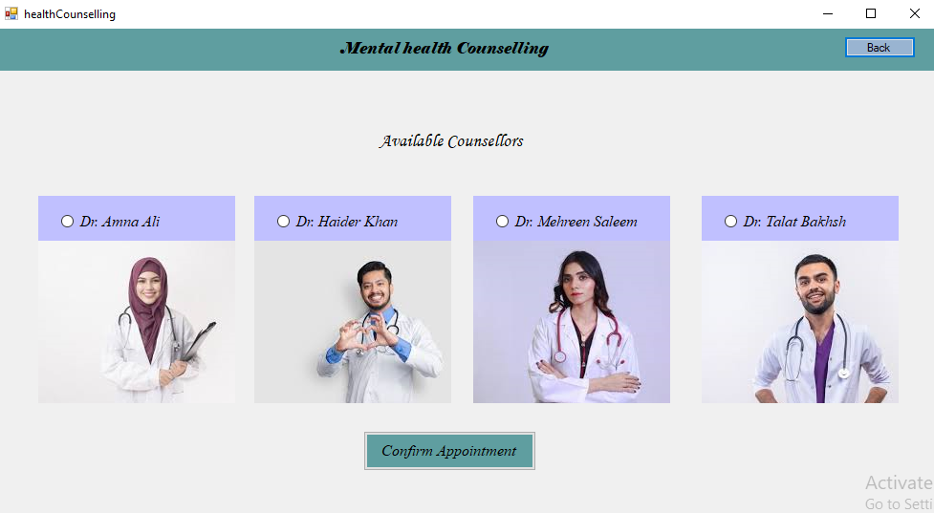

Here you select the number of the semester for which you want a transcript

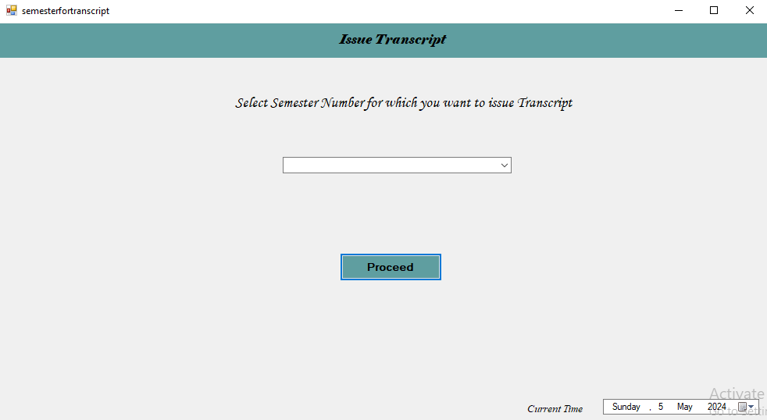

Enter your batch, roll number and name

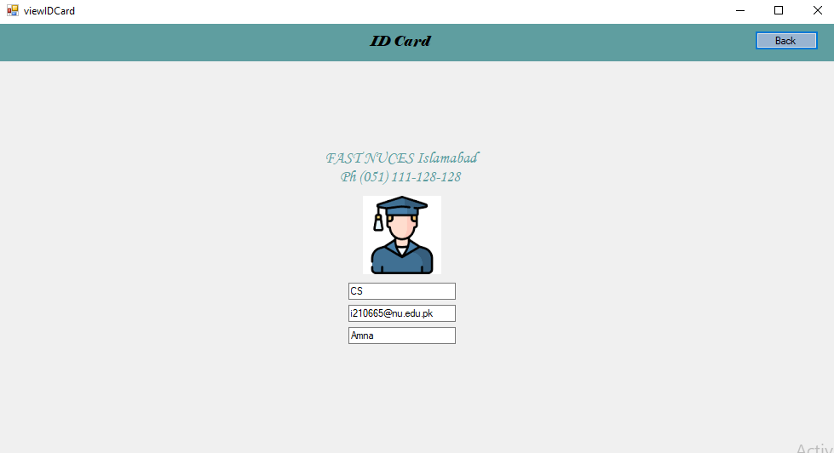

Enter your username and password

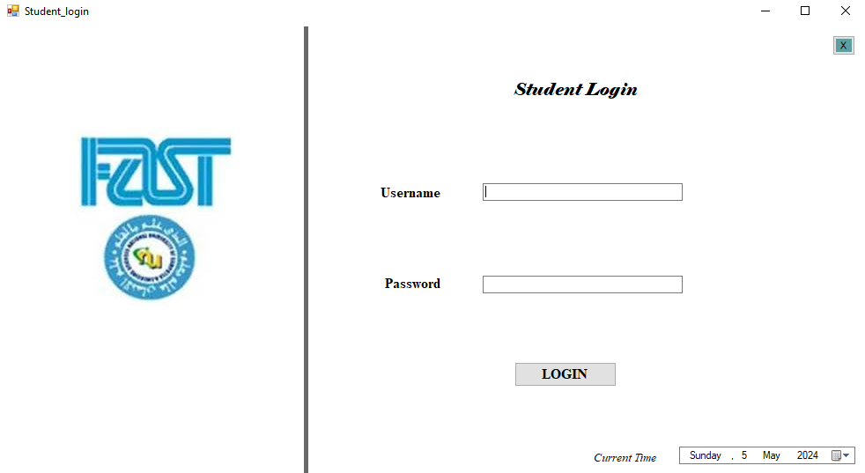

Enter the lost and found IA, the item that was lost, and where it was found and how long it was lost for

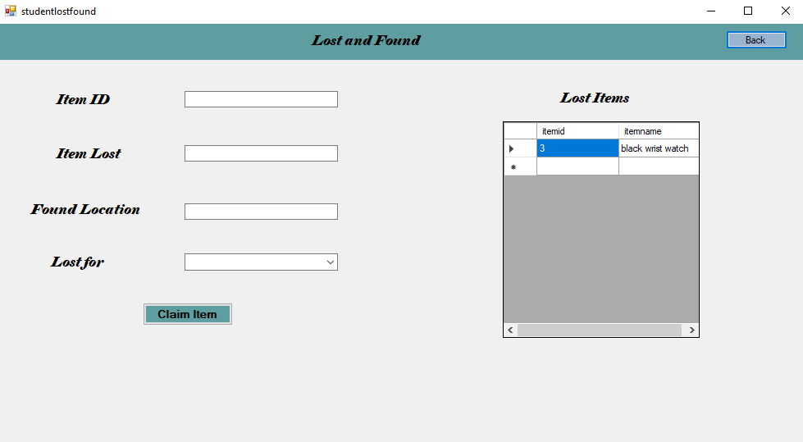

This is the page after logging in, choose what you want to do in this website

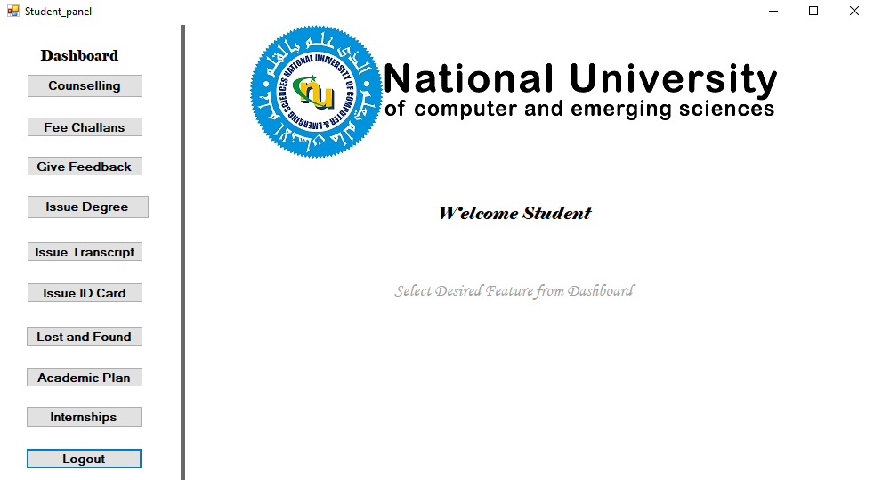

Here you register yourself  
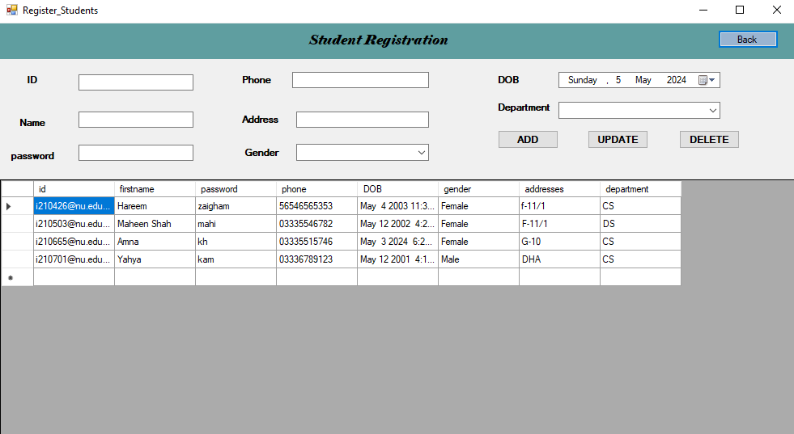

This is a page where you view challans  
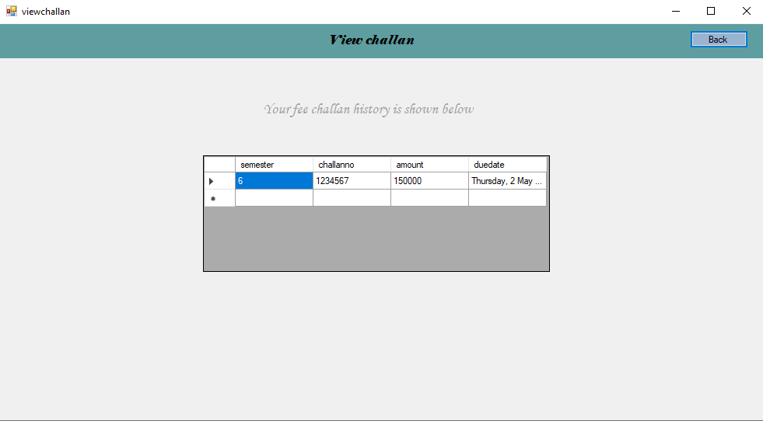

The following is the academic calendar

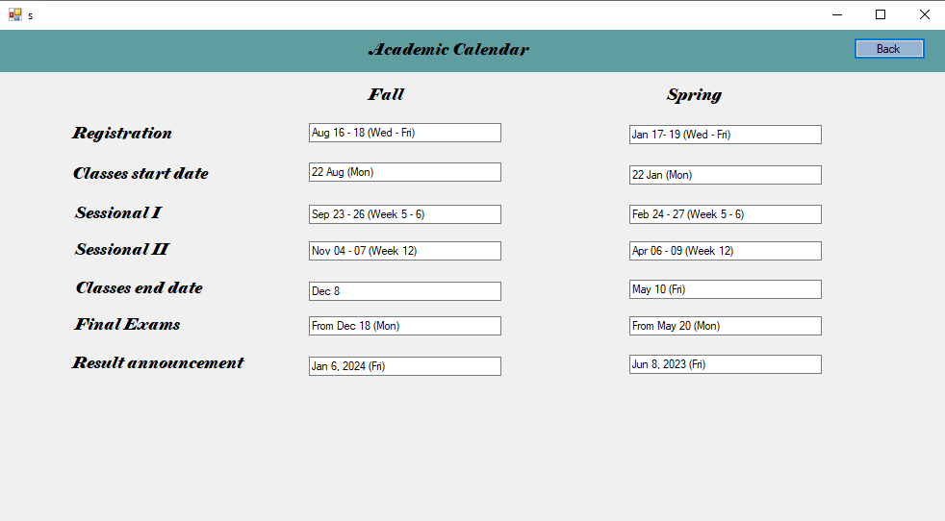

The following is the degree issued

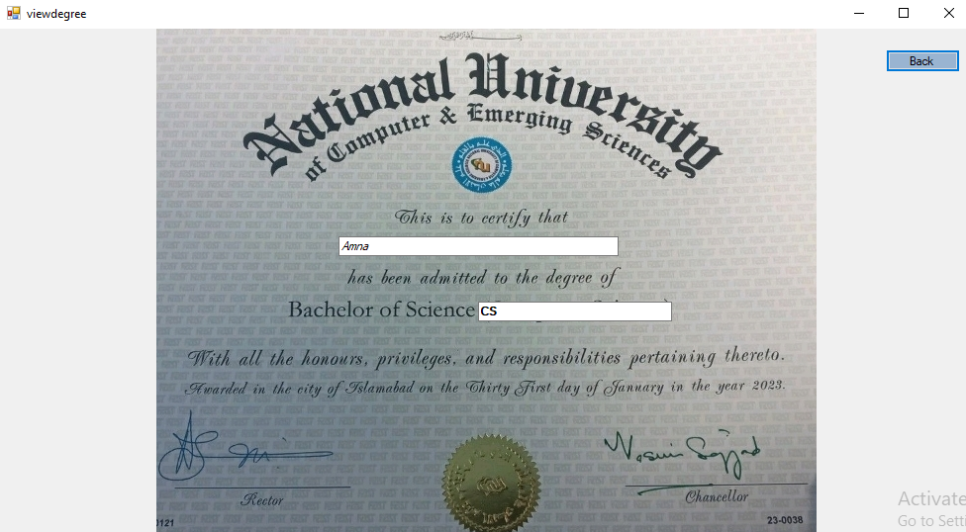

The following is the view of your salary

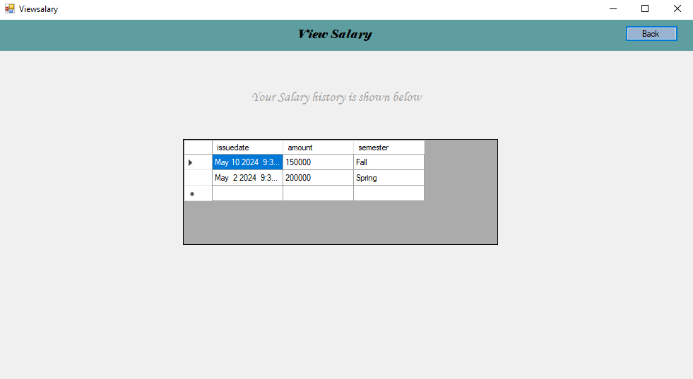

The following is the view of your transcript

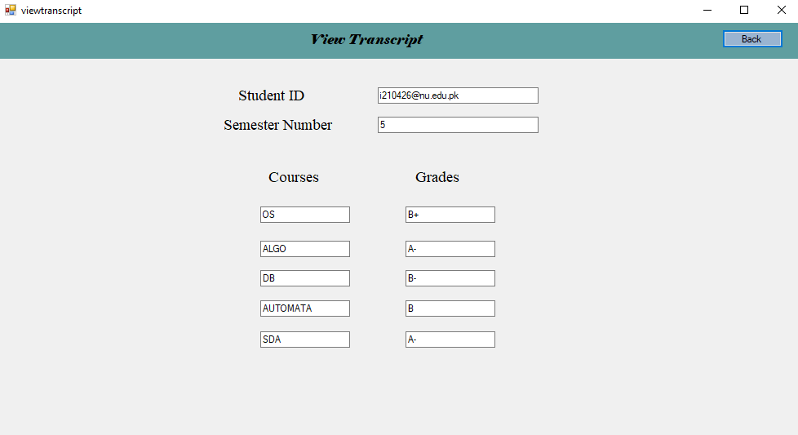

This is the page that proves that the transcript request has been successfully processed

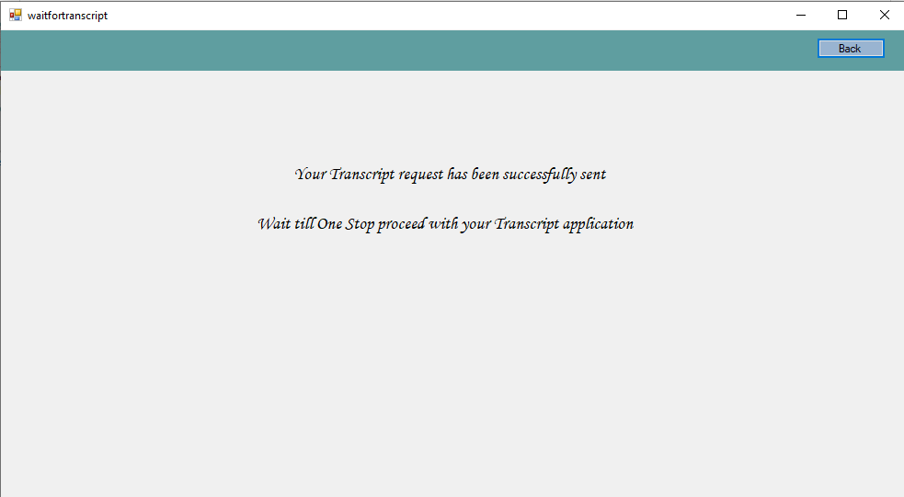

The following is the login page for admin

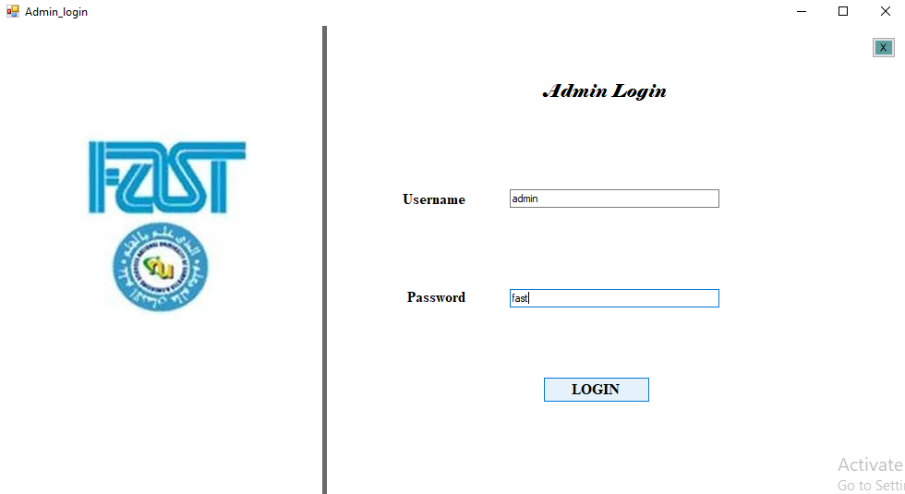

This is an admin home page

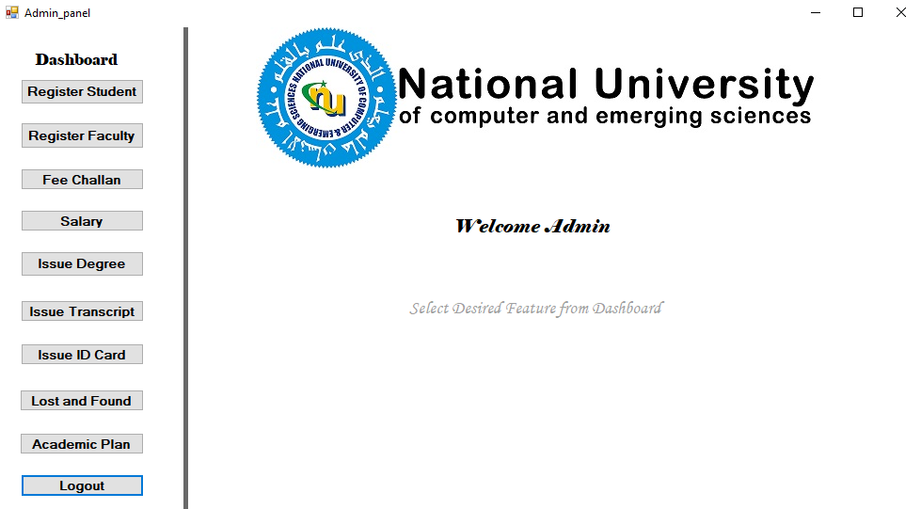

The following are all the internship opportunities

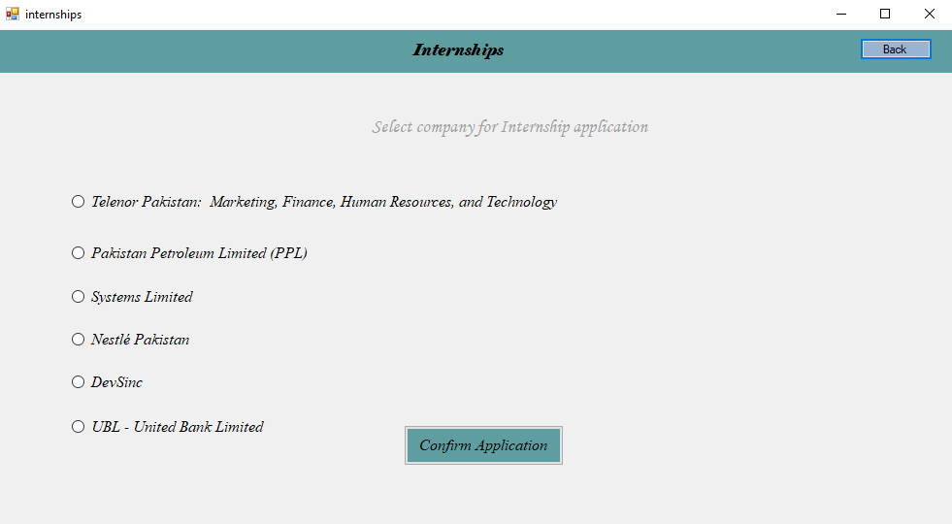

You can choose one of the following for career counselling

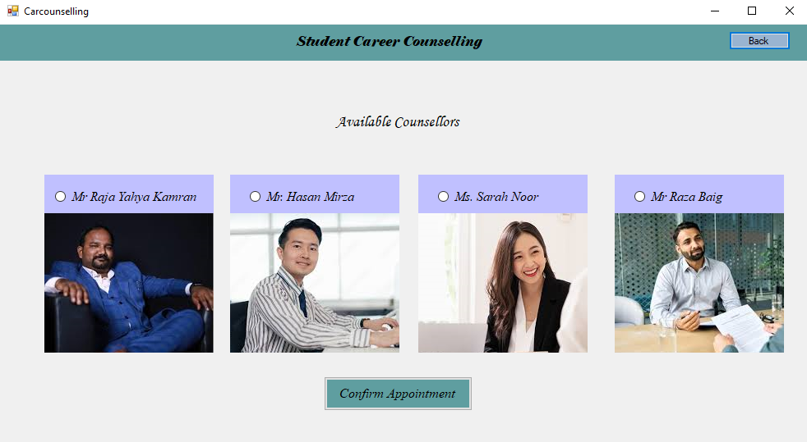

you can choose if u want career or mental counseling

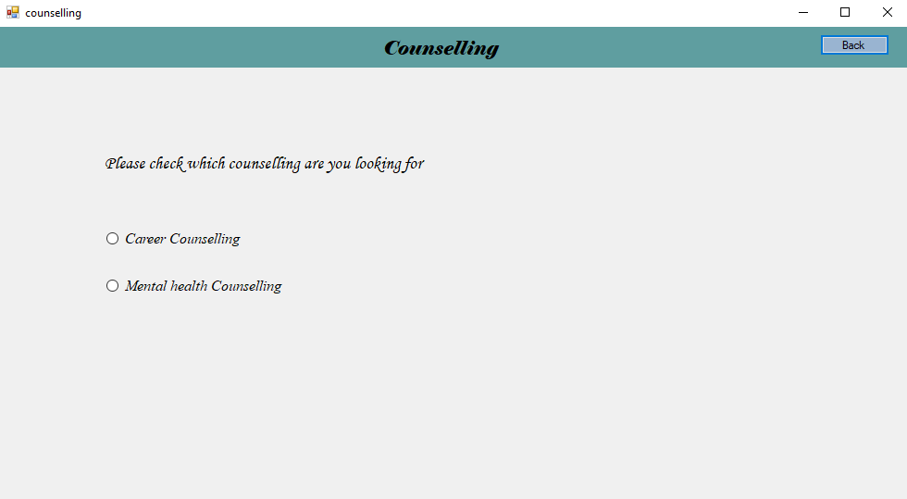

Here you can submit the feedback

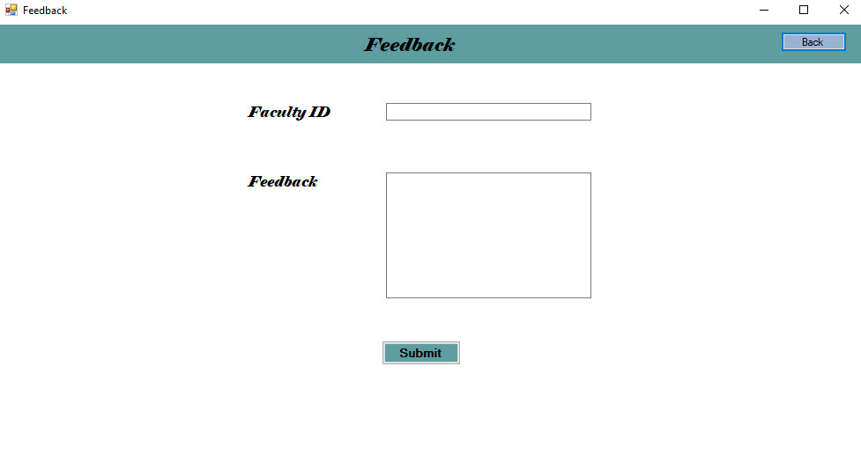

This is the login and sign up page for faculty

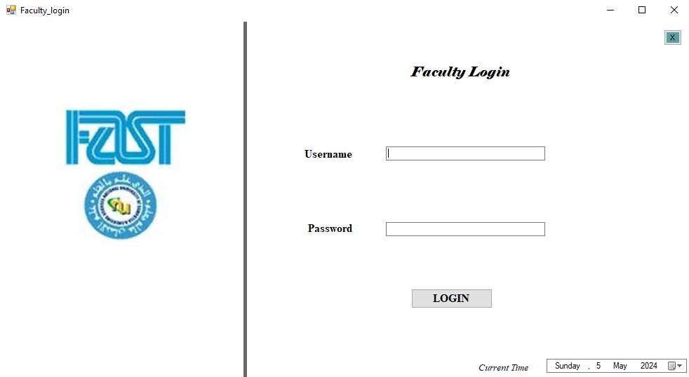

Home page for faculty



Registration for faculty

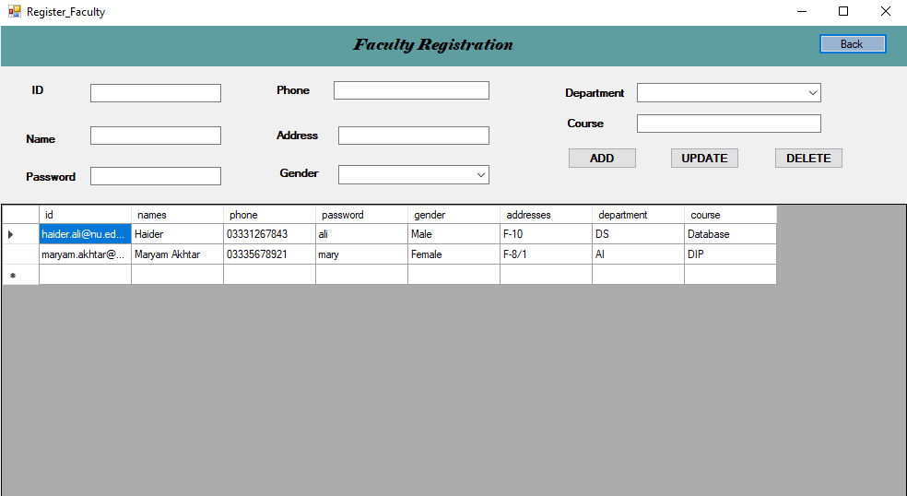

Choose if u are a student, admin or faculty member

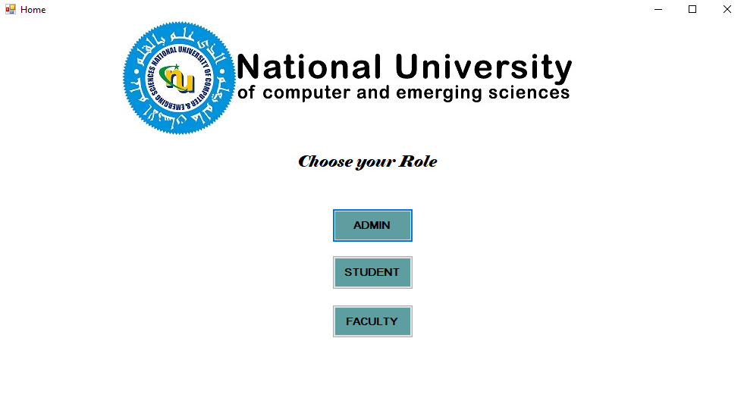

The following is the degree issuance

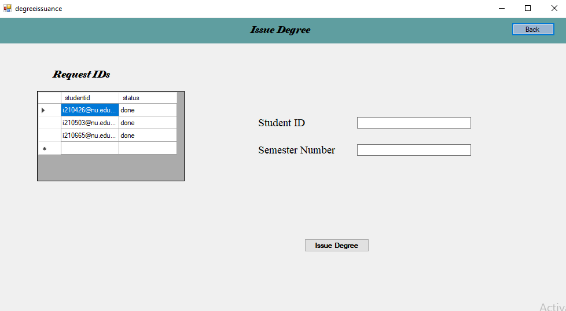

FOllowing is the fee challan issuance

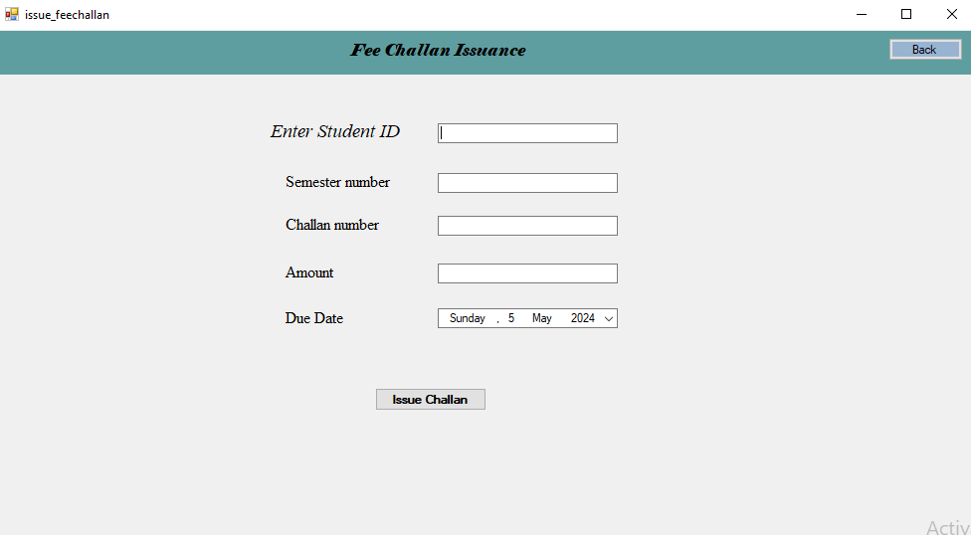

The following is the Salary issuance

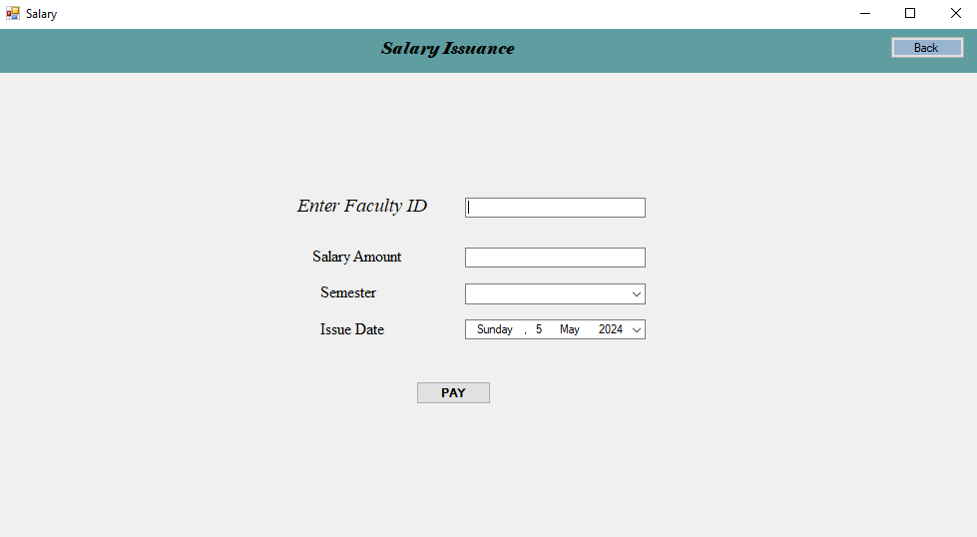

The following is the transcript issuance

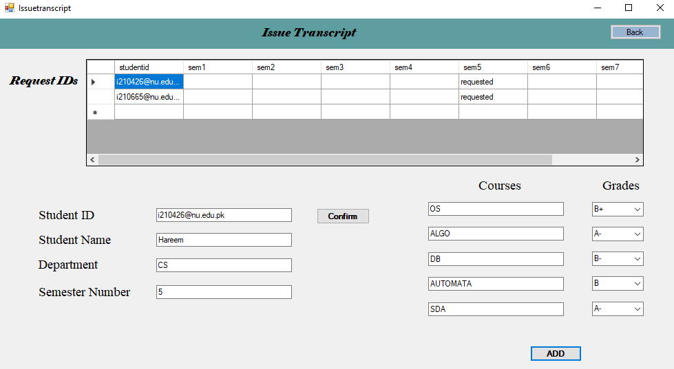



**User Story 1:**

Equivalent Class Partitions:

*Table 2: User Story 1*

| **Input or Output Event** | **Valid Equivalence Classes** | **Invalid Equivalence Classes** |
| --- | --- | --- |
| *Name* field—The Admin has to enter the employee’s name | Alphabetic,  3 chars long name at least | Not Alphabetic  length is less than 3. |
| *Email* field—The Admin has to enter the employee’s email. | @, .com is a must | No @ or .com provided |
| *Username* field—The Admin has to create a username which will be used for login credentials of employee. | Length at least 4 and at max 10,  Alphanumeric | Length<4  Length>10  Not Alphanumeric |
| *Gender* field—The Admin has to select gender of the employee. | One Checkbox selected | No Checkbox selected |
| *Employee Number* field—The Admin has to provide an employee number to the employee. | Length==6 digits,  Numeric only | Length < 6 digits  Length > 6 digits  Not Numeric |
| *Phone Number*—The Admin has to provide the employee’s phone number. | 7 digits<= Length <= 15 digits,  Numeric Only (no +, - sign) | Length < 7 digits  Length > 15 digits  Not Numeric |
| *Password*—The Admin has to provide a password for account so employees can securely access their account. | An upper-case alphabet, a lower-case alphabet, a non-letter character,  6 chars<= Length <= 10 chars | No Upper Case Alphabet  No Lower-Case Alphabet  No non-letter characters  Length < 6 chars  Length > 10 chars |
| *Address*—The Admin has to provide the complete address of the employee. | Length >= 15 characters (to have complete address) | Length < 15 (Incomplete Address) |

Boundary Value Analysis:

*Table 3: User Story 1 - Boundary Value*

| **Input** | **Boundary Value** |
| --- | --- |
| Name | Length of Name=3 is the boundary value and should be accepted |
| Username | Length of Username=4 and Username=10 are the boundary values and should be accepted |
| Employee Number | Length of Employee Number=6 is the boundary value and should be accepted |
| Phone Number | Length of Phone Number=7 and Username=15 are the boundary values and should be accepted |
| Password | Length of Password=6 and Username=10 are the boundary values and should be accepted |
| Address | Length of Address=15 is the boundary value and should be accepted |

**User Story 2:**

Equivalent Class Partitions:

*Table 4: User Story 2*

| **Input or Output Event** | **Valid Equivalence Classes** | **Invalid Equivalence Classes** |
| --- | --- | --- |
| *Name* field—The Patient has to enter their Name. | Alphabetic,  3 chars long name at least | Not Alphabetic  length is less than 3. |
| *Email* field--The Patient has to enter their Email. | @, .com is a must | No @ or .com provided |
| *Username* field—The Patient has to create a username which will be used for login credentials. | Length at least 4 and at max 10,  Alphanumeric | Length<4  Length>10  Not Alphanumeric |
| *Gender* field—The Patient has to select gender. | One Checkbox selected | No Checkbox selected |
| *CNIC* field—The Patient has to provide their CNIC. | Length==11 digits,  Numeric only | Length < 11 digits  Length > 11 digits  Not Numeric |
| *Phone Number*—The Patient has to provide their phone number | 7 digits<= Length <= 15 digits,  Numeric Only (no +, - sign) | Length < 7 digits  Length > 15 digits  Not Numeric |
| *Password*—The Patient has to provide a password so that they securely access their account. | An upper-case alphabet, a lower-case alphabet, a non-letter character,  6 chars<= Length <= 10 chars | No Upper Case Alphabet  No Lower-Case Alphabet  No non-letter characters  Length < 6 chars  Length > 10 chars |
| *Address*—The Patient has to provide their complete address. | Length >= 15 characters (to have complete address) | Length < 15 (Incomplete Address) |

Boundary Value Analysis:

*Table 5: User Story 2- Boundary Value*

| **Input** | **Boundary Value** |
| --- | --- |
| Name | Length of Name=3 is the boundary value and should be accepted |
| Username | Length of Username=4 and Username=10 are the boundary values and should be accepted |
| CNIC | Length of CNIC=11 is the boundary value and should be accepted |
| Phone Number | Length of Phone Number=7 and Username=15 are the boundary values and should be accepted |
| Password | Length of Password=6 and Username=10 are the boundary values and should be accepted |
| Address | Length of Address=15 is the boundary value and should be accepted |

**User Story 3:**

Equivalent Class Partitions:

*Table 6: User Story 3*

| **Input or Output Event** | **Valid Equivalence Classes** | **Invalid Equivalence Classes** |
| --- | --- | --- |
| Name field for name of Employee/Patient whose record you want to search. | Alphabetic,  3 chars long name at least | Not Alphabetic  length is less than 3. |
| Choose a Designation for user searching. | Designation selected | Designation not selected |
| ***BUTTONS with Input***  *Search Patient/Employee* Button—to go to the page for name, designation | Clicked | Not Clicked |
| *Search* Button—to search results | Clicked | Not Clicked |
| *Back to Dashboard* Button—to go back to Patient’s Dashboard | Clicked | Not Clicked |
| *Back to Search* Button—to go back to Search Page again after viewing the available users. | Clicked | Not Clicked |
| *View* Button—to view complete details of a user from a list of users which were searched with the same name and designation. | Clicked | Not Clicked |
| *Back to Search Results* Button—to go back to the users searched with same name and designation, from view details page. | Clicked | Not Clicked |
| ***Separate Button for Deletion***  *Delete* Button—to delete a user from a list of users displayed, the admin can permanently delete user account from this. | Clicked | Not Clicked |

No Boundary Value Analysis possible for this user story.

**User Story 4:**

Equivalent Class Partitions for Patient Manage Account:

*Table 7: User Story 4*

| **Input or Output Event** | **Valid Equivalence Classes** | **Invalid Equivalence Classes** |
| --- | --- | --- |
| *Name* field—The Patient can update their name. | Alphabetic,  3 chars long name at least | Not Alphabetic  length is less than 3. |
| *Email* field--The Patient can update their email. | @, .com is a must | No @ or .com provided |
| *Username* field—The Patient cannot update their username. | Not Updated | Updated |
| *Gender* field—The Patient can update their gender. | One Checkbox selected | No Checkbox selected |
| *CNIC* field—The Patient can update their CNIC. | Length==11 digits,  Numeric only | Length < 11 digits  Length > 11 digits  Not Numeric |
| *Phone Number*—The Patient can update their Phone Number | 7 digits<= Length <= 15 digits,  Numeric Only (no +, - sign) | Length < 7 digits  Length > 15 digits  Not Numeric |
| *Password*—The Patient can update their password for account’s login credentials. | An upper-case alphabet, a lower-case alphabet, a non-letter character,  6 chars<= Length <= 10 chars | No Upper Case Alphabet  No Lower-Case Alphabet  No non-letter characters  Length < 6 chars  Length > 10 chars |
| *Address*—The Patient can update their address. | Length >= 15 characters (to have complete address) | Length < 15 (Incomplete Address) |
| *Update Button:* The Patient can edit the GUI fields and update their information. | Clicked—Updated | Not Clicked—Not Updated |
| *Delete Button:* The Patient can delete their account permanently from the system. | Clicked—Deleted | Not Clicked—Not Deleted |
| *Back to Home Button:* The Patient can use this button for going back to Patient’s Dashboard. | Clicked | Not Clicked |

Boundary Value Analysis for Patient Manage Account:

*Table 8: User Story 4 - Boundary Value 1*

| **Input** | **Boundary Value** |
| --- | --- |
| Name | Length of Name=3 is the boundary value and should be accepted |
| CNIC | Length of CNIC=11 is the boundary value and should be accepted |
| Phone Number | Length of Phone Number=7 and Username=15 are the boundary values and should be accepted |
| Password | Length of Password=6 and Username=10 are the boundary values and should be accepted |
| Address | Length of Address=15 is the boundary value and should be accepted |

Equivalent Class Partitions for Employee Manage Account:

*Table 9: User story 4 - Employee*

| **Input or Output Event** | **Valid Equivalence Classes** | **Invalid Equivalence Classes** |
| --- | --- | --- |
| *Name* field—The employee can update their name. | Alphabetic,  3 chars long name at least | Not Alphabetic  length is less than 3. |
| *Email* field—The employee can update their email. | @, .com is a must | No @ or .com provided |
| *Username* field—The employee cannot update their username. | Not Updated | Updated |
| *Gender* field—The employee can update their gender. | One Checkbox selected | No Checkbox selected |
| *Employee Number* field—The employee can update their employee number. | Length==6 digits,  Numeric only | Length < 6 digits  Length > 6 digits  Not Numeric |
| *Phone Number*—The employee can update their phone number. | 7 digits<= Length <= 15 digits,  Numeric Only (no +, - sign) | Length < 7 digits  Length > 15 digits  Not Numeric |
| *Password*—The employee can update their password. | An upper-case alphabet, a lower-case alphabet, a non-letter character,  6 chars<= Length <= 10 chars | No Upper Case Alphabet  No Lower-Case Alphabet  No non-letter characters  Length < 6 chars  Length > 10 chars |
| *Address*—The employee can update their address. | Length >= 15 characters (to have complete address) | Length < 15 (Incomplete Address) |
| *Update Button:* The Employee can edit the GUI fields and update their information. | Clicked—Updated | Not Clicked—Not Updated |
| *Delete Button:* The Employee can delete their account permanently from the system. | Clicked—Deleted | Not Clicked—Not Deleted |
| *Back to Home Button:* The Employee can use this button for going back to Patient’s Dashboard. | Clicked | Not Clicked |

Boundary Value Analysis for Employee Manage Account:

*Table 10: User Story 4 - Boundary Value 2*

| **Input** | **Boundary Value** |
| --- | --- |
| Name | Length of Name=3 is the boundary value and should be accepted |
| Employee Number | Length of Employee Number=6 is the boundary value and should be accepted |
| Phone Number | Length of Phone Number=7 and Username=15 are the boundary values and should be accepted |
| Password | Length of Password=6 and Username=10 are the boundary values and should be accepted |
| Address | Length of Address=15 is the boundary value and should be accepted |

**User Story 5: Couselling**

Equivalent Class Partitions User Story 5:

*Table 11: User Story 5*

| **Input or Output Event** | **Valid Equivalence Classes** | **Invalid Equivalence Classes** |
| --- | --- | --- |
| *option to choose between career and mental health counseling* | Clicked | Not Clicked |
| select an option out of 2 | selected | Nothing selected |
| *Selected counselor*. | Any, some or all of the counselors clicked | No checkbox selected. (Error message displayed and checkboxes are disabled) |
| confirmation | Clicked | Not Clicked |
| *Back to Dashboard* Button—to go back to Dashboard | Clicked | Not Clicked |

No Boundary Value Analysis specific values.

**User Story 6:**

Equivalent Class Partitions User Story 6:

*Table 12: User Story 6*

| **Input or Output Event** | **Valid Equivalence Classes** | **Invalid Equivalence Classes** |
| --- | --- | --- |
| *View Predictions* Button—to move to the page where patient’s all predicted disease chances are shown, and a View More Description button is provided for disease | Clicked | Not Clicked |
| *Back to Dashboard* Button—to go back to Patient’s Dashboard | Clicked | Not Clicked |
| *View* Button—to redirect Patient to an online link for detailed description of the chosen disease. | Clicked | Not Clicked |
| *Sign Out* Button—displayed on View Predictions page for signing out. | Clicked | Not Clicked |

No Boundary Value Analysis is possible for User Story 6.

Equivalent Class Partitions for ID Issuance:

*Table 9: User story 4 - Employee*

| **Input or Output Event** | **Valid Equivalence Classes** | **Invalid Equivalence Classes** |
| --- | --- | --- |
| *Roll number Field-*  *The student can click the yes or no button for the issuance* | clicked | not clicked |
| *Confirmation- Employee confirms that the student has paid his debts* | Employee confirms | Employee doesnt confirm |
| *ID card is issued* | Printed | Not printed |
| *Gender* field—The employee can update their gender. | One Checkbox selected | No Checkbox selected |

Boundary Value Analysis for Employee ID issuance:

*Table 10: User Story 4 - Boundary Value 2*

| **Input** | **Boundary Value** |
| --- | --- |
| Roll number | Only numbers are accepted |
| email | only @ and .com at the end are accepted |

Equivalent Class Partitions for Transcript Issuance:

*Table 9: User story 4 - Employee*

| **Input or Output Event** | **Valid Equivalence Classes** | **Invalid Equivalence Classes** |
| --- | --- | --- |
| *Roll number Field-*  *The student can click the yes or no button for the issuance* | clicked | not clicked |
| *Confirmation- Employee confirms that the student is eligible* | Employee confirms | Employee doesnt confirm |
| *Transcript is issued* | Printed | Not printed |
| *Gpa is above 2.0* | issue transcript | ask for signature of parents |

Boundary Value Analysis for Employee Transcript issuance:

*Table 10: User Story 4 - Boundary Value 2*

| **Input** | **Boundary Value** |
| --- | --- |
| Roll number | Only numbers are accepted |
| email | only @ and .com at the end are accepted |
| Transcript | gpa is above 2.0 |

Equivalent Class Partitions for Admit card Issuance:

*Table 9: User story 4 - Employee*

| **Input or Output Event** | **Valid Equivalence Classes** | **Invalid Equivalence Classes** |
| --- | --- | --- |
| *Roll number Field-*  *The student can click the yes or no button for the issuance* | clicked | not clicked |
| *Confirmation- Employee confirms that the student has paid his debts* | Employee confirms | Employee doesnt confirm |
| *ID card is issued* | Printed | Not printed |

Boundary Value Analysis for Employee Admit card issuance:

*Table 10: User Story 4 - Boundary Value 2*

| **Input** | **Boundary Value** |
| --- | --- |
| Roll number | Only numbers are accepted |
| email | only @ and .com at the end are accepted |

Equivalent Class Partitions for Fee Challan generation:

*Table 9: User story 4 - Employee*

| **Input or Output Event** | **Valid Equivalence Classes** | **Invalid Equivalence Classes** |
| --- | --- | --- |
| *Fee challen button clicked* | clicked | not clicked |
| *Confirmation- Employee confirms that the fee challan isnt paied* | Employee confirms | Employee doesnt confirm |
| *Fee challan is issued* | Fee not paid | Fee paid |

NO Boundary Value Analysis for Fee Challan Generation:

*Table 10: User Story 4 - Boundary Value 2*

Equivalent Class Partitions for Degree Issuance:

*Table 9: User story 4 - Employee*

| **Input or Output Event** | **Valid Equivalence Classes** | **Invalid Equivalence Classes** |
| --- | --- | --- |
| *Student selects button to generate Degree* | clicked | not clicked |
| *Confirmation- Employee confirms that the student has completed his credit hours* | Employee confirms | Employee doesnt confirm |
| *An issue request is generated* | Request sent | Request not sent |

No Boundary Value Analysis for Degree issuance:

Equivalent Class Partitions for Degree Tracking:

*Table 9: User story 4 - Employee*

| **Input or Output Event** | **Valid Equivalence Classes** | **Invalid Equivalence Classes** |
| --- | --- | --- |
| *Students and employee can Track the degree* | Degree sent | Degree not sent |
| *Student/Employee Clicks button* | Tracker shows | Tracker doesnt show |

No Boundary Value Analysis for Degree issuance:

Equivalent Class Partitions for Degree Notifying:

*Table 9: User story 4 - Employee*

| **Input or Output Event** | **Valid Equivalence Classes** | **Invalid Equivalence Classes** |
| --- | --- | --- |
| *Employee sends clicks button to inform that degree has arrived* | Degree Arrived | Degree not arrived |
| *Employee updates the dataset* | Employee confirms that degree has reached | Employee doesnt confirm that degree has reached |
| *Student clicks button to see his notifications* | Notification sent | Notification not sent |

No Boundary Value Analysis for Degree issuance:

Equivalent Class Partitions for Admit card Issuance:

*Table 9: User story 4 - Employee*

| **Input or Output Event** | **Valid Equivalence Classes** | **Invalid Equivalence Classes** |
| --- | --- | --- |
| *Student Clicks button to inform* | clicked | not clicked |
| *Confirmation- Employee confirms that the student has paid his debts* | Employee confirms | Employee doesnt confirm |
| *ID card is issued* | Printed | Not printed |

Boundary Value Analysis for Admit card issuance:

*Table 10: User Story 4 - Boundary Value 2*

| **Input** | **Boundary Value** |
| --- | --- |
| Roll number | Only numbers are accepted |
| email | only @ and .com at the end are accepted |

**Product Review:**

* The one stop student service center offers a comprehensive amount of features catering to the needs of students, faculty and admins alike. It covers a wide variety of functionalities including counseling services, ID card issuance, feedback management, lost and found etc.
* One of the features of this website is its clear help provided for each role, be it faculty or administrator or student, so that there is relevancy to each corresponding role and each and every person can use this website freely according to their convenience.
* Previously internships and mental and career counsllings were scarce, now we have made them all readily available for willing and students in need, to cater to students and faculty alike.
* Looking forward, this website has a potential to evolve beyond just a website, perhaps the development of a mobile application could extend the reach of the availability of the platform itself.
* Overall, the onestop student service center provides a decent foundation to facilitate users, administrators and faculty alike, and with continuous refinement, it may potentially be a very useful and beneficial tool for all members of the university.